**AS400 THEORY NOTES**

[https://github.com/skill-at/AS-400-Training/wiki --> From sir](https://github.com/skill-at/AS-400-Training/wiki     --> From sir)

[ashwin417/as400_myNotes](https://github.com/ashwin417/as400_myNotes) 🡪 from Ashwin

The Application system/400 was the result of the “**Silver Lake project**” at IBM’ - on **21st June 1988**

**ADTS(Application Development Tool Set)**

* PDM (Program Development Manager) . Command to start : STRPDM
* SEU (Source Entry Utility) . Command to start STRSEU
* SDA (Screen Design Aid) . Command to Start STRSDA
* RLU (Report Layout Utility) . Command to start STRRLU
* DFU (Data File Utility). Command STRDFU

**System architecture**

There are three categories of software on the AS/400:

* Application Software - PDM
* Operating System Software - CL
* System Licensed Internal Code (SLIC)

**Client Access Software:**

* Enable communication between client and server.
* IBM Personal Communication
* RENEX
* MOCHA SOFT (TN5250)
* RUMBA/400

**ASP(Auxiliary Storage Pool)**

The logical partition on AS/400 is called as Auxiliary Storage Pool (ASP). The ASP is like C drive D drive etc on Personal Computers except that the ASPs on AS/400 are numbered.

Within ASP are what are called as Libraries.

**TYPES OF LIBRARIES**

For one job max of 25 libs can be defined

* System
* Product
* Current library
* User library

**STANDARD RECORD LENGTHS OF SRCPF**

QRPGSRC, QDDSSRC, QDDLSRC, QCLSRC, QCMDSRC, etc - record length of 92

QRGLESRC - a record length of 112 (92 default + 20 bytes of comment)

Source physical file is an object. But the source member is not an object. When we compile the member, the object is created for that source.

AS400 LIMITS (refer github)

**AS400 jobs (Batch job detailed)**

A job is a piece of work that is done on AS400. Job name is composed of Job Number/User/Job Name.

Interactive jobs in AS400?

It requires user to be always interactive/signed in till the time job runs. It doesn’t wait in line for system resources.

Batch job.

Batch job is a predefined group of processing actions submitted to the system to be performed with little or no interaction between the user and the system. Jobs that do not require user interaction to run can be processed as batch jobs. A batch job typically is a low priority job and can require a special system environment in which to run. Batch jobs run in the system background, freeing the user who submitted the job to do other work. Several batch jobs can be active at the same time.

Flow of a Batch Job

✓ **SBMJOB** command is run to start the batch job.

✓ Goes to Job Queue and waits for its turn with status **JOBQ**

✓ Become **ACTIVE** when its turns come/enters subsystem

✓ Goes to Output Queue (**OUTQ**) after getting finished.

✓ Spool file Moves to **Print Writer**

✓ Prints out on **Printer**

Job description:

It is AS400 object of type *JOBD

Contains a specific set of job related attributes. Attributes determine how each job is run on the system. ✓ Values in the Job Description can be overridden during the run of commands SMBJOB • Can specify: ✓ Initial library list ✓ Job Queue ✓ Job Priority: of jobs using this job description. ✓ Output Queue

Job queue :Whenever a batch job is submitted it goes to the place so called Job Queue where it waits for its turn to get processed based on its priority. This priority is called as job priority.

Values for job priority are from 1 to 9 , 1 being highest and 9 being lowest

Output Queue

Output queue contains spool files waiting for its turn to get printed. This is based on output priority 1 being highest and 9 being lowest

Run priority

This is priority which job uses when it is active Specifies the run priority for the job. Run priority is a value,

ranging from 1 (highest priority) through 99 (lowest priority), that represents the priority at which the job competes for the processing unit relative to other jobs that are active at the same time.

Subsystem :

The subsystem is the work place for jobs on your system. All user work is done by jobs running in the subsystem and it is important to monitor this area for slow work performance.

Object types :- *sbsd (subsystem description) command : WRKSBSD SUBSYSTEME NAME *jobq (Job queue) command : WRKJOBQ JOBQUEUE NAME *outq Command : wrkoutq outq name

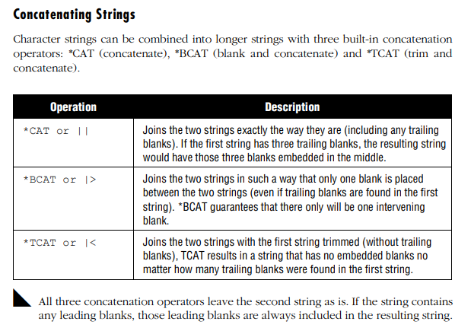

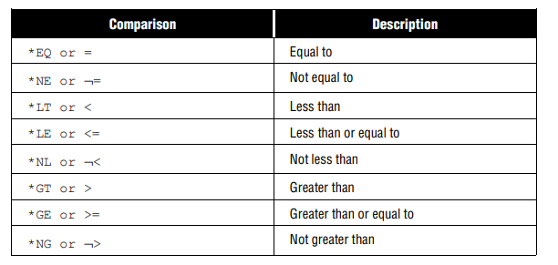

**SUBROUTINES IN CL**

SUBR (Subroutine) command is used in CL program to begin the subroutine block.

ENDSUBR (End Subroutine) command is used in CL program to end the subroutine block.

CALLSUBR(Call Subroutine) command is used in CL program to execute/call a subroutine.

RTNSUBR command is used to return a value and exit the subroutine when RTNVAL is optional to use.

**CRTDUPOBJ V/S CPYF**

In CRTDUPOBJ for a logical file the created duplicate file will be also logical file and for a physical file the created file will also be a physical file. Even the record format identifier will also be the same. While in case of CPYF, if we are copying a logical file then the created file be a physical file not a logical file.

Commitment control is a function that ensures data integrity. It defines and processes a group of changes to resources, such as database files or tables, as a transaction.

A physical file is composed of three components, namely,

Record Format

Access Path

Data Member

**ENTRIES LEVELS IN PHYSICAL FILE**

There are four levels of entries that the physical file contains in a specific order as described below:

File Level – UNIQUE, FIFO,LIFO,FCFO,REF,REFFLD

Record Format Level – FORMAT, TEXT

Field Level – ALIAS,ALWNULL,CMP/COMP,COLHDG,DATFMT,DATESEP,REFFLD,TEXT,TIMFMT,TIMSEP,VALUES,VARLEN

Key Field Level-ABSVAL,DESCEND,DIGIT,SIGNED,UNSIGNED

A Logical file (LF) with Keys are Access path (INDEX) over the physical file (PF)

A Logical file (LF) with no key are VIEWS over the physical file (PF).

If there is/are Logical files (LF) present for a physical file (PF) then we cannot delete Physical file (PF) until and unless we delete all the dependent Logical files (LF) over that physical file (PF). But Logical file (LF) can be deleted without deleting the Physical file (PF) first.

**TYPES OF LF**

Non-Join Logical File

Single Record Format Logical File

File level keyword -- PFILE

Multiple Record Format Logical File

Join Logical File (LF)

File level – JDFTVL(LEFT OUTER JOIN)

Join level – JDUPSEQ,JOIN,JFLD

Record – JFILE

Field – JREF

**JOURNALING**

Four basic journal entry categories

· The most common journal entries fall into four basic categories (J, F, R, C).

· Within each category there are number of different journal entry types represented by a two-character entry code (e.g. PR, NR for journal entry J).

Journal and journal receiver operations (J). These include such things as references to the previous receiver (PR) or the next receiver (NR) in a chain. Also, at IPL-time, an entry is made (e.g., an IN entry for IPL after normal end) marking a critical chronological boundary in the file activity.

File operations (F). This category includes file opens (OP) and file closes (CL).

Record operations (R). Record updates (UP), deletes (DL), and new records written (PT and PX) all fall into this category.

Commitment control (C). Anything related to commitment control falls into this category. Some examples are begin commitment control (BC), start a commit cycle (SC), commit operation (CM) and rollback operation (RB).

To get journal entries use DSPJRN command , either take output to OUTFILE or display results. Example : - DSPJRN JRN(JRNFILE) FILE((EMPPF)) RCVRNG(*CURCHAIN) OUTPUT(*OUTFILE) OUTFILFMT(*TYPE3) OUTFILE(PRAF12121/JRNOUTPUT)

**RPGLE built in functions**

1. %SUBST
2. %SCAN
3. %CHAR
4. %XLATE
5. %LEN
6. %TRIM,%TRIML,%TRIMR
7. %CHECK
8. %CHECKR
9. %DEC
10. %DATE
11. %DAYS
12. %MONTHS
13. %YEARS
14. %TIMESTAMP

SQL 🡪 RCDFMT 🡪 RENAME

To allow lowercase values, go to edit change source settings "Change session defaults" or F13. Then change uppercase input only to N.

SQL - CREATE OR REPLACE TABLE(not null with default, primary key), CREATE VIEW...AS..[CAST,ROUND], CURRENT DATE TIME, INDEX(create unique index indexname on tablename(key1,key2)), DROP(equivalent to dltf or wrkobj filename 4), Alter table(equivalent in dds -- chgpf), flatfiles(files without str), DELETE FROM(equivalent to clrpfm clear phy member

**COMMAND LIST**

1. CRTLIB
2. CHGCURLIB
3. DSPLIBL
4. DSPLIB
5. DLTLIB
6. EDTLIBL
7. ADDLIBLE
8. WRKLIBPDM
9. DSPSYSVAL/QSYSLIBL
10. DSPSYSVAL QUSRLIBL
11. RMVLIBLE
12. WRKMBRPDM
13. STRDBG
14. DSPFD
15. DSPFFD
16. CRTSRCPF
17. WRKJOB
18. SBMJOB
19. SBSD
20. WRKJOBQ
21. WRKACTJOB
22. WRKSBSD
23. WRKOUTQ
24. WRKACTJOB SBS(SUBSYSTEM Name)
25. WRKUSRJOB
26. WRKSBSJOB
27. WRKSBS
28. WRKSBMJOB
29. DSPMSG
30. DSPMSG QSYSOPR
31. WRKOBJLCK
32. DSPRCDLCK
33. CRTDUPOBJ
34. RCVF – CPF0864 - original program model (OPM) program
35. CLOF
36. SNDRCVF
37. DCLF – RCDFMT
38. CPYF – DROP,MAP,NOCHK REPLACE,ADD CRTFILE(YES)🡪CURLIB

Copy records where EMPCITY starts with 'H' (First character is 'H') # INCCHAR parameter

CPYF FROMFILE(*LIBL/EMPPF) TOFILE(*LIBL/EMPPFBK) FROMMBR(*FIRST) TOMBR(*FIRST) MBROPT(*REPLACE) CRTFILE(*NO) FROMRCD(*START) INCCHAR(EMPCITY 1 *EQ 'H')

Field test (INCREL) parameter using relational operator

1. MONMSG
2. STRCMTCTL
3. ENDCMTCTL
4. STRRLU
5. CRTDTAARA
6. RTVDTAARA
7. CHGDTAARA
8. DSPDTAARA
9. DLTDTAARA
10. CRTPF
11. CHGPF
12. CRTLF
13. DSPDBR
14. ADDPFM – MAXMBRS(While CHGPF)
15. OVRDBF
16. STRSQL
17. RUNSQLSTM
18. OPNQRYF
19. DLTOVR
20. SNDMSG
21. SNDUSRMSG
22. SNDPGMMSG
23. SNDBRKMSG
24. CLRPFM
25. RMVM
26. CPYFRMIMPF
27. CPYTOIMPF
28. CRTJRNRCV
29. CRTJRN
30. STRJRN
31. ENDJRN
32. ADDPFTRG
33. RUNQRY
34. WRKQRY
35. UPDDTA
36. CHGCURDIR
37. CHGOWN
38. MOV
39. RMVLNK
40. WRKAUT
41. WRKLNK
42. ENDJOB
43. ENDSBS
44. HLDJOBQ
45. RLSJOBQ
46. SBMJOB
47. STRSBS
48. CHGJOB
49. DSPJOBLOG
50. WRKSYSSTS
51. CRTSAVF
52. RSTOBJ
53. SAVOBJ
54. SAVLIB
55. CHGAUT
56. EDTOBJAUT
57. GRTOBJAUT
58. RVKOBJAUT
59. CRTOUTQ
60. CRTDEVPRT
61. STRRMTWRTR
62. WRKOUTQ
63. WRKSPLF
64. DLTSPLF
65. WRKWTR
66. CRTUSRPRF
67. WRKUSRPRF
68. CRTBNDDIR
69. WRKBNDDIR
70. CRTSRVPGM
71. UPDSRVPGM
72. STRPGMEXP
73. ENDPGMEXP
74. DSPSRVPGM
75. CRTPRTF
76. DSPSYSVAL
77. DLTF
78. DSPPGMREF
79. CRTDSPF
80. DSPPGM
81. RCLACTGRP
82. FNDSTRPDM
83. CPYSPLF
84. ADDPFCST